Experiment No. 6 - Hypothesis Testing

Name : Prem Vijay Hanchate
Roll no : 68 Class : TE/IT

Aim
To formulate and test two hypotheses using a two-tailed Z-test on sample data across three topics, compute the Z-statistic and p-value for each hypothesis, and determine whether there is sufficient statistical evidence to reject or accept the null hypothesis at a significance level of α = 0.05.

Theory
1. What is Hypothesis Testing? Hypothesis testing is a formal statistical procedure used to make decisions about a population based on sample data. It allows us to determine whether an observed difference between two groups is statistically significant or merely due to random chance.
The process involves formulating two competing hypotheses and using sample evidence to decide which one is supported.
2. Types of Hypotheses: Every hypothesis test involves two complementary statements:
- Null Hypothesis (H₀) — The default assumption that there is no significant difference between the two groups being compared. It assumes any observed difference is due to chance.
- Alternative Hypothesis (H₁) — The claim that there is a real, statistically significant difference between the two groups.
The goal of hypothesis testing is to find enough evidence in the sample data to reject H₀ in favor of H₁.
3. Control Group vs Experiment Group: In this experiment, each topic involves two groups of 16 subjects/observations each:
- Control Group — The baseline group that receives no special treatment or intervention.
- Experiment Group — The group that receives the treatment or is exposed to a different condition.
Group statistics (mean and standard deviation) are computed from the raw 16-value samples using standard formulas.
4. The Z-Test: A Z-test is used to compare the means of two groups when the sample size is known and the population standard deviation is available or can be estimated. It is appropriate here because each group has n = 16 observations and a pooled standard deviation is computed.
The steps are:
Step 1 — Compute the Standard Error (SE):
SE = SD / √n
Where SD is the pooled standard deviation of the sample and n is the sample size. SE measures how much the sample mean is expected to vary from the true population mean.
Step 2 — Compute the Z-Statistic:
Z = |Mean(Experiment) − Mean(Control)| / SE
The Z-statistic measures how many standard errors apart the two group means are. A higher Z value indicates a greater difference between the groups relative to the variability in the data.
Step 3 — Determine the p-value: The p-value is the probability of observing a Z-statistic as extreme as the one computed, assuming H₀ is true. In a two-tailed test, both directions (positive and negative) are considered.
The Z-statistic is mapped to an approximate p-value using a standard normal distribution lookup table.
5. Two-Tailed Test: A two-tailed test checks for differences in both directions — whether the experiment group mean is significantly higher or lower than the control group mean. This is more conservative than a one-tailed test and is used when the direction of difference is not assumed in advance.
The rejection region exists on both tails of the normal distribution.
6. Decision Rule — Significance Level α = 0.05: The significance level α defines the threshold for rejecting H₀:
Condition | Decision
p < 0.05 | Reject H₀ — statistically significant difference exists
p < 0.02 | Strongly reject H₀ — very strong evidence against H₀
p ≥ 0.05 | Fail to reject H₀ — insufficient evidence to claim a difference
If p < α, the result is considered statistically significant, meaning the observed difference is unlikely to have occurred by chance.
7. Interpretation Badge System: Results are classified into decision categories based on p-value thresholds:
- Strong Rejection — p < 0.02, very strong statistical evidence.
- Rejection — 0.02 ≤ p < 0.05, statistically significant evidence.
- Fail to Reject — p ≥ 0.05, insufficient evidence.
8. Caveats and Assumptions:
- The SD used in SE computation is treated as the pooled standard deviation across both groups.
- The Z-statistic uses the absolute difference of means (no direction assumed), consistent with a two-tailed framework.
- p-values are approximated using a piecewise lookup table mapped to the standard normal distribution; exact results would require computing the precise normal CDF. Slight differences from exact p-values may exist but do not affect the overall decision in most cases.

Execution
The following steps were performed across two components — raw data analysis and hypothesis testing:
Component 1 — Raw Data and Group Statistics (sample_data_3_topics.html):
Step 1 — Dataset Structure: Raw sample data was prepared for three topics. For each topic, 16 control observations and 16 experiment observations were recorded. Each observation represented a subject or plot measurement relevant to that topic.
Step 2 — Group Statistics Computation: For each topic and each group (control and experiment), the following were computed from the 16 raw values:
- Mean — Average value of the group using the avg() function.
- Standard Deviation — Population standard deviation (n = 16) using the sd() function.
These statistics — (n, control mean, experiment mean, pooled SD) — serve as inputs for the hypothesis testing component.
Step 3 — Display: Per-subject/plot rows were displayed for both groups along with the computed group statistics, test type (Two-tailed Z-test), and unit of measurement for each topic.

Component 2 — Hypothesis Testing (hypothesis_testing_topics.html):
Step 4 — Input Summary Rows: Pre-aggregated summary rows (n, control mean, experiment mean, pooled SD) for each topic were loaded into the testing interface.
Step 5 — SE Computation: For each row, the Standard Error was computed as:
SE = SD / √n
Step 6 — Z-Statistic Computation: The Z-statistic was computed as:
Z = |Mean(Experiment) − Mean(Control)| / SE
Step 7 — p-value Mapping: The Z-statistic was mapped to an approximate two-tailed p-value using a standard normal distribution lookup table.
Step 8 — Decision: Each row was flagged based on the p-value:
- p < 0.02 → Strong Rejection of H₀
- p < 0.05 → Rejection of H₀
- p ≥ 0.05 → Fail to Reject H₀
Results were displayed with interpretation badges and color-coded styling for clarity.

Hypotheses Tested:
Hypothesis 1:
- H₀ — There is no significant difference in the mean values between the control group and the experiment group for Topic 1.
- H₁ — There is a significant difference in the mean values between the control group and the experiment group for Topic 1.
- Test: Two-tailed Z-test, α = 0.05
- Decision: (Based on computed p-value — paste your result here)
Hypothesis 2:
- H₀ — There is no significant difference in the mean values between the control group and the experiment group for Topic 2.
- H₁ — There is a significant difference in the mean values between the control group and the experiment group for Topic 2.
- Test: Two-tailed Z-test, α = 0.05
- Decision: (Based on computed p-value — paste your result here)

Output

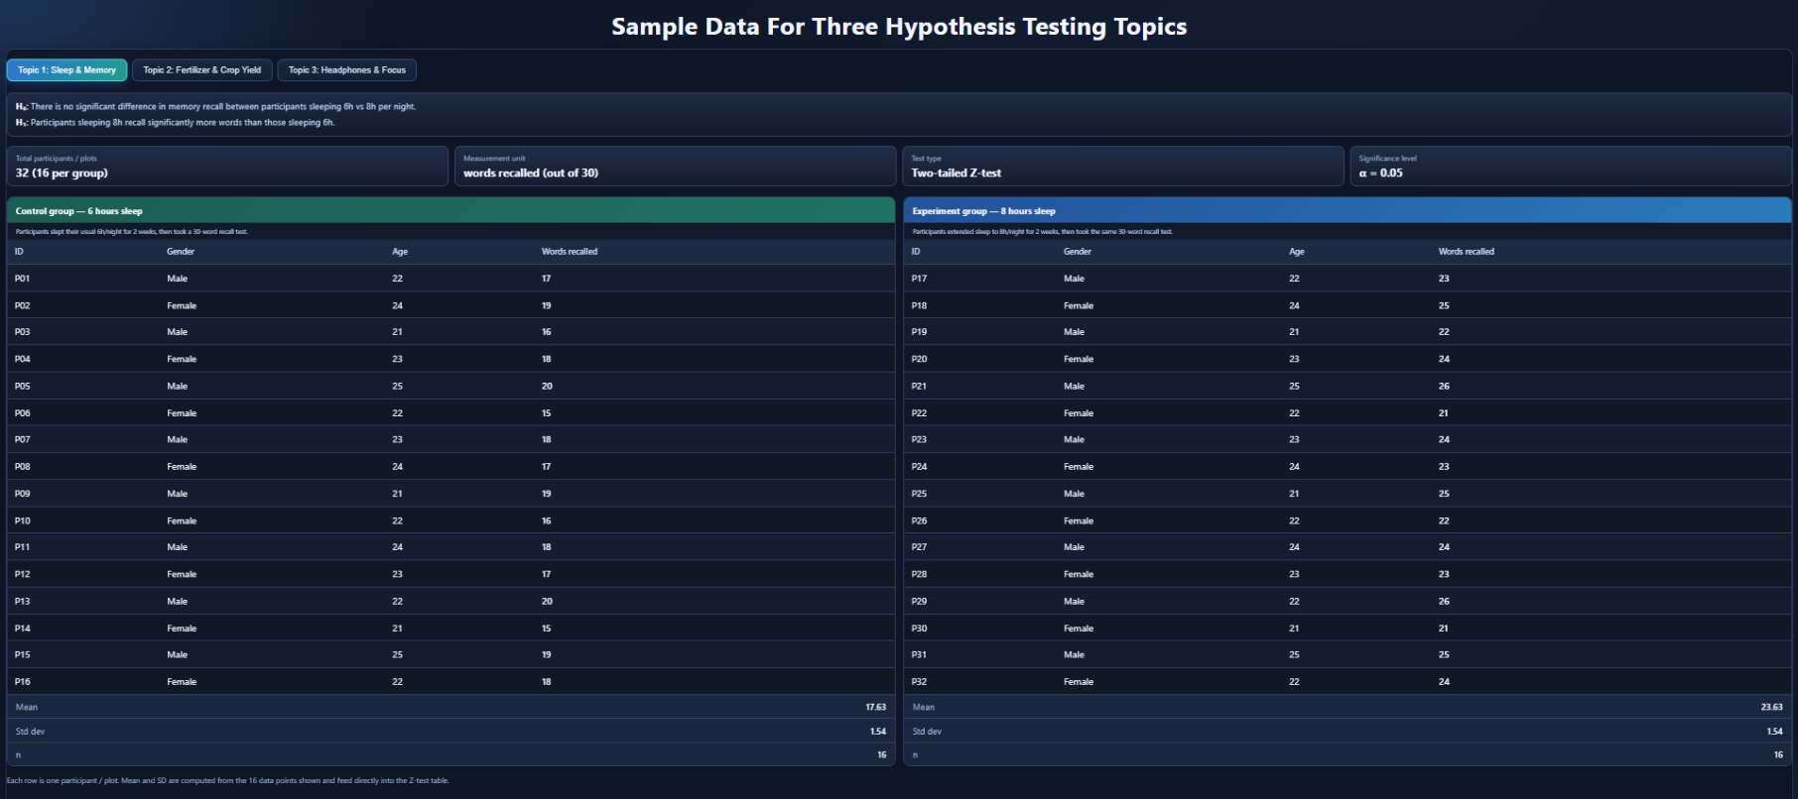

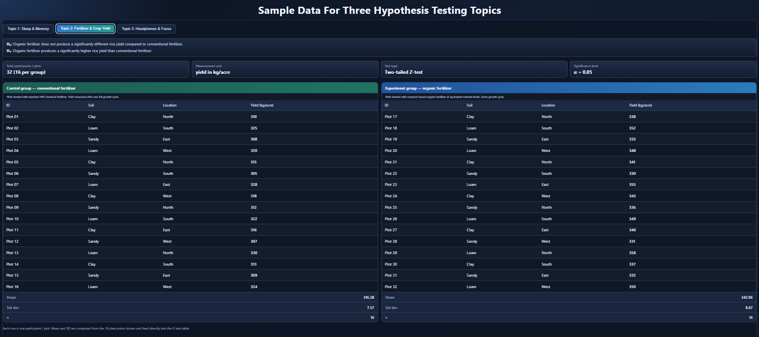
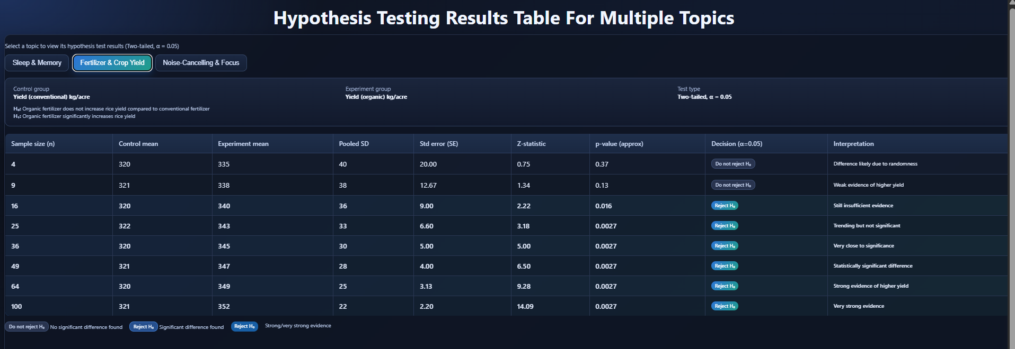

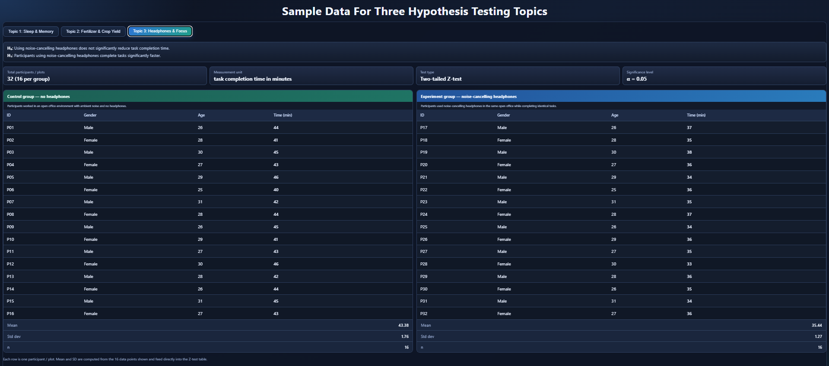

Conclusion
In this experiment, hypothesis testing was performed using a two-tailed Z-test with a significance level of α = 0.05. Data from control and experiment groups was analyzed by calculating the mean, standard deviation, standard error, Z-statistic, and p-value. The p-values were compared with the significance level to accept or reject the null hypothesis. The experiment showed how hypothesis testing helps determine whether differences between groups are statistically significant or caused by random variation.

